

Cockatoo Skatepark
Upgrade

Traffic & Pedestrian Management Plan

October 2010

Table of Contents

1. Project Information 3
1.1. Introduction 4
1.2. Description of work 4
1.3. Site Location 4
1.4. Proposed Access 4
1.5. Traffic and Pedestrian Management Plan 4

- Project Information

Site Location/ Address: | Alma - Trelore Reserve (Corner McBride & Neville St), Cockatoo
Project Name: | Cockatoo Skatepark Upgrade
Project No:
Principal Contractor: | Convic Skate Parks Pty Ltd
 | Unit 13, 46-50 Regent Street, Richmond VIC
 | Ph, 03 9486 9899, fax 03 9486 9088
Principal Contractor ABN: | 40804672322
Project Manager | Steve Kassab
Site Supervisor: | Jack Bohmer
Safety Officer: | Jack Bohmer
First Aid Officer: | Jack Bohmer
Phone: | 0488 034 009
Fax:
Client/Council: | Cardinia Shire Council
 | Council Offices
 | PO Box 7
 | Henry Way
 | Pakenham VIC 3810
Forecast Start: | 15/11/2010
Forecast Completion: | 17/12/2010
Principal Contractor Sign-off | Andrew Barr

  - Introduction
This traffic and pedestrian management plan has been prepared by Dave Hogan, Project Engineer, Convic Skate Parks Aust. for the construction of the Cockatoo Skate Park Upgrade. The plan is in accordance with AS1742.3-2002 Manual of Uniform Traffic control Devices, Part 3: Traffic Control Devices for Works on Roads.

  - Description of work
Demolition and construction of concrete skate facility including earthworks, formwork, reinforcing, and concrete placement/ finishing. Skate facility approximately 220 m2 in concrete area. The works are due to commence on site 15/11/10 and is forecast to be completed 17/12/10

  - Site Location
The site is located at Alma - Trelore Reserve, bounded by McBride St, Neville St, and Pakenham Road.
The construction of the skate facility will consist of the following activities and associated plant/ equipment.

Earthworks / Demolition | Excavator, vibrating pad foot roller, trucks to remove any spoil.
Materials Delivery | Various flatbed trucks delivering steel and other miscellaneous equipment/ materials
Concrete | Concrete trucks, boom pump

  - Proposed Access
The site is to be accessed via the site entry identified as "Site Entry Point 1" which is located via the bitumen road running off Pakenham Road behind the existing skate bowl.
Trucks entering signage will be located on Pakenham Road, 150metres either side of the site access point. Both of these signs will be utilized during the period of construction.
Traffic Controllers will be utilized on an as needed basis.
The site will be fenced off at all stages of the Construction process as is indicated in the site plan

  - Traffic and Pedestrian Management Plan
Refer to the attachement site plan.

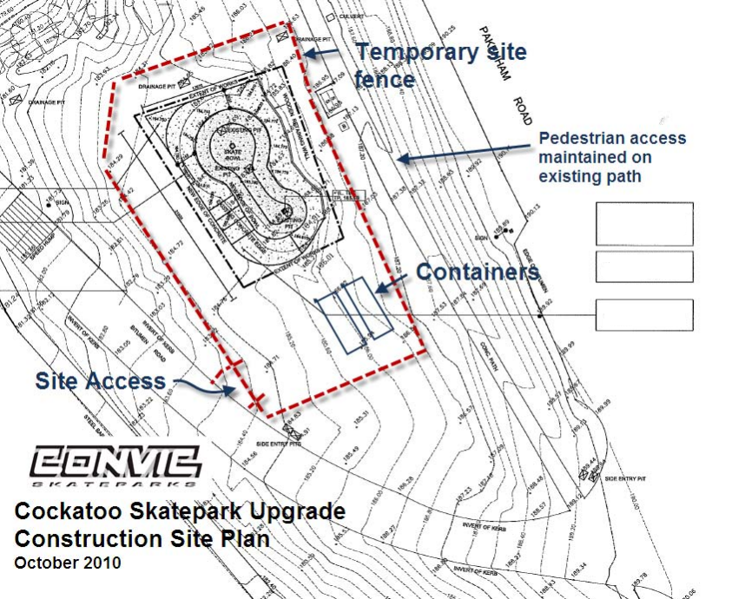
ALL EXISITING DRAINAGE PITS AND GRATES TO BE PROTECTED THROUGHOUT CONSTRUCTION.
NEW PIT LIDS TO BE FITTED TO FINISH FLUSH WITH NEW CONCRETE POUR.
DRAINAGE AND NUMBER OF PITS TO BE CONFIRMED ON SITE DURING CONSTRUCTION. REFER TO DRAINAGE DETAIL 06_7
400 HIGH EXTENSION WITH ROLLER ON ONE SIDE WITH A RAMPED PLATFORM ON THE OTHER.

